CHAPTER 3

PROPOSED METHOD

3.1 Application of k-means Clustering on a Data Set

The procedure follows a simple and easy way to classify a given data set through a certain number of clusters (assume k clusters) fixed apriori. The main idea is to define k centers, one for each cluster. These centers should be placed in a cunning way because of different location causes different result. So, the better choice is to place them as much as possible far away from each other. The next step is to take each point belonging to a given data set and associate it to the nearest center. When no point is pending, the first step is completed and an early group age is done. At this point we need to re-calculate k new centroids as barycenter of the clusters resulting from the previous step. After we have these k new centroids, a new binding has to be done between the same data set points and the nearest new center. A loop has been generated. As a result of this loop we may notice that the k centers change their location step by step until no more changes are done or in other words centers do not move any more [https://sites.google.com/site/dataclusteringalgorithms/k-means-clustering-algorithm]

Problem: Cluster the following eight points (with (x, y) representing locations) into three clusters A1(2, 10) A2(2, 5) A3(8, 4) A4(5, 8) A5(7, 5) A6(6, 4) A7(1, 2) A8(4, 9). Initial cluster centers are: A1(2, 10), A4(5, 8) and A7(1, 2). The distance function between two points a=(x1, y1) and b=(x2, y2) is defined as: ρ(a, b) = |x2 – x1| + |y2 – y1| .

Solution:

Iteration 1
 |  | (2, 10) | (5, 8) | (1, 2)
 | Point | Dist Mean 1 | Dist Mean 2 | Dist Mean 3 | Cluster
A1 | (2, 10)
A2 | (2, 5)
A3 | (8, 4)
A4 | (5, 8)
A5 | (7, 5)
A6 | (6, 4)
A7 | (1, 2)
A8 | (4, 9)

First we list all points in the first column of the table above. The initial cluster centers – means, are (2, 10), (5, 8) and (1, 2) - chosen randomly. Next, we will calculate the distance from the first point (2, 10) to each of the three means, by using the distance function:

Iteration 1
 |  | (2, 10) | (5, 8) | (1, 2)
 | Point | Dist Mean 1 | Dist Mean 2 | Dist Mean 3 | Cluster
A1 | (2, 10) | 0 | 5 | 9 | 1
A2 | (2, 5) | 5 | 6 | 4 | 3
A3 | (8, 4) | 12 | 7 | 9 | 2
A4 | (5, 8) | 5 | 0 | 10 | 2
A5 | (7, 5) | 10 | 5 | 9 | 2
A6 | (6, 4) | 10 | 5 | 7 | 2
A7 | (1, 2) | 9 | 10 | 0 | 3
A8 | (4, 9) | 3 | 2 | 10 | 2

After first iteration
Cluster 1 contains the points (2, 10)
Cluster 2 contains the points (8, 4) (5, 8) (7, 5) (6, 4) (4, 9)
Cluster 3 contains the points (2, 5) (1, 2)

Next, we need to re-compute the new cluster centers (means). We do so, by taking the mean of all points in each cluster.

For Cluster 1, we only have one point A1(2, 10), which was the old mean, so the cluster center remains the same.

For Cluster 2, we have ( (8+5+7+6+4)/5, (4+8+5+4+9)/5 ) = (6, 6)

For Cluster 3, we have ( (2+1)/2, (5+2)/2 ) = (1.5, 3.5)

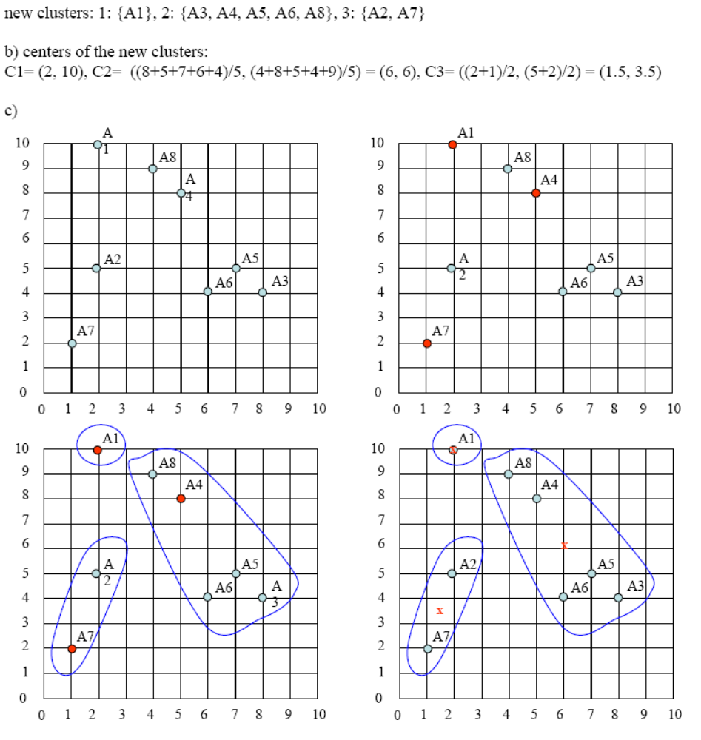
The initial cluster centers are shown in red dot. The new cluster centers are shown in red x. That was Iteration1 (epoch1). Next, we go to Iteration2 (epoch2), Iteration3, and so on until the means do not change anymore. In Iteration2, we basically repeat the process from Iteration1 this time using the new means we computed.

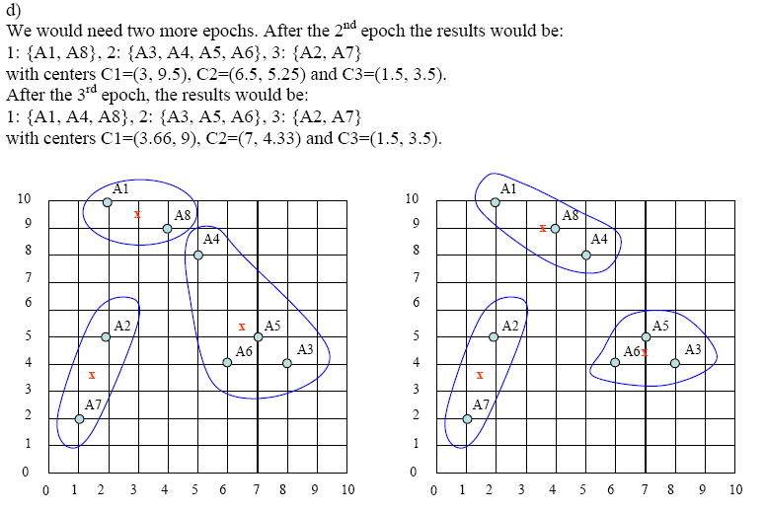
But due to drawbacks of k-means algorithm that it works with only numerical value we need to have a technique capable of working with both numerical and categorical values. K-prototype solves this purpose by applying data mining and forming clusters based on the both numerical and categorical values .

